**Hyde, Robin (1906-1939)**

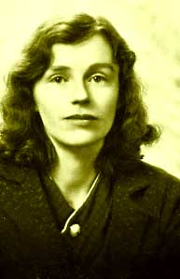SUMMARY

Hyde in 1934, studio portrait taken by Herbert Tornquist,

New Zealand Electronic Poetry Centre: http://www.nzepc.auckland.ac.nz/authors/hyde/

Robin Hyde is the pseudonym of New Zealand poet, novelist, short story writer, and journalist Iris Guiver Wilkinson. Hyde published numerous volumes of poetry and prose, as well as countless articles on New Zealand life and politics before committing suicide at the age of 33. While a major figure of local New Zealand literature, Hyde also spans international interests, especially through her travel writings on Hong Kong and China during the Japanese occupation of the 1930s and 40s. Much of her work merges conventions of novel, biography, fantasy, and documentary to depict the daily realities of post-colonial New Zealand life while also voicing some of the country’s major political and cultural concerns post-World War I.

ENTRY

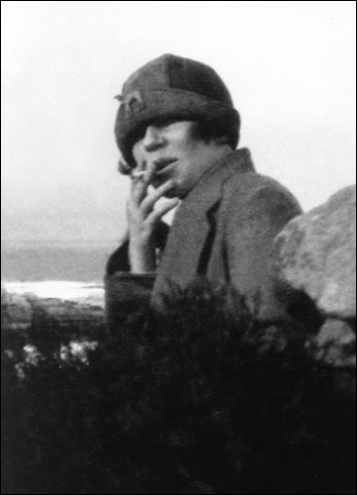Hyde was born in Cape Town, South Africa to an Anglo-Indian father and Australian mother; the family moved to New Zealand when Hyde was a year old. She began writing poems and stories at an early age and winning writing contests at her school, The Wellington Girls’ College. After briefly attending Victoria University, Hyde began her lifelong career as a journalist with her local newspaper the *Dominion*, where she edited and wrote stories for the paper’s children’s section. Although she was hospitalized for several months in 1924 for a knee injury that left her with permanent damage and pain, Hyde resumed writing for the *Dominion* in 1925 in a new position as a columnist reporting on parliamentary proceedings for the women’s section. She went on to hold various writing and editing positions at the *Women’s Mirror*,the *Christchurch Sun*, and the *Waganui Chronicle*, as well as the *New Zealand Observer*. Her account *Journalese* (1934) chronicles her experiences as one of the few female journalists on the New Zealand reporting scene in the early twentieth century.

Hyde in 1928 on the Lyall Bay foreshore

New Zealand Electronic Poetry Centre:

<http://www.nzepc.auckland.ac.nz/authors/hyde/gallery5.asp>

While continuing her career as a journalist, Hyde published poetry, novels, and short stories prolifically. She took her nom de plume from her son by Frederick de Mulford Hyde, Christopher Robin Hyde, who died shortly after birth. Her first publication under this pseudonym, ‘Conflagration” (1927) appeared in the *Christchurch Sun*. Her first book of poems, *The Desolate Star* (1929) followed soon after.

In 1933, Hyde was arrested for attempting suicide and became a voluntary patient at an Auckland mental hospital. She was then transferred to Wolf Home where she remained for the next four years. Given her own room, time away from her demanding reporting schedule, and encouragement from her doctors, Hyde published and completed several of her major works during this time. Her work from this period often fused fictional and nonfictional elements to bring otherwise marginalized or neglected characters and issues to the forefront of New Zealand’s history and culture. Hyde’s first novel *Check to your King* (1935) depicts Baron de Thierry, who sought to create a utopian kingdom in the Hokianga area of northern New Zealand in the nineteenth century. *Passport to Hell* (1936) novelizes the life of Douglas Stark, an Auckland prison inmate Hyde had met a few years prior and who was known just as much for his exceptional military service in World War I as for his 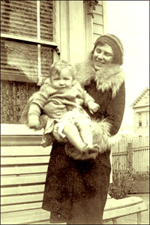multiple assault and petty theft sentences during and after the war. Hyde shed light on New Zealand women caught between the demands of tradition and modernity in the novel *Wednesday’s Children* (1937), which features a childless protagonist who lives with her half-brother while managing to convince her family and neighbours that she owns an island in the Harukai Gulf, where her five illegitimate children by fathers of different nationalities reside with a Maori nanny. While institutionalized, Hyde also began work on *The Godwits Fly* (1938). Largely based on her upbringing and coming of age in Wellington, this semi-autobiographical novel addresses the New Zealand writers of her generation who found themselves at a crossroads between New Zealand roots and affinities for England.

Hyde with son Derek Challis, 1931

*Jacket* magazine: <http://jacketmagazine.com/25/hyde-ash.html>

Hyde’s own journey to England brought her to Japanese-occupied China in 1938. Commissioned to write travel pieces, Hyde set out for England by way of Hong Kong and then, witnessing the plight of refugees from eastern China, decided to enter China for herself in hopes of writing about it. She stayed with American missionaries during the bombing and occupation of Hsuchow and walked along the northern railway line to escape to Tsingtao, where Japanese officials escorted her to the British Consulate. Hyde published poems, articles, and the travel book *Dragon Rampant* (1939) based on these experiences.

In 1939, Hyde committed suicide by an overdose of Benzedrine. Although she was largely relegated to obscurity in the decades immediately following her death, feminist scholarship of the 1980s rekindled interest in Hyde’s life and work. Hyde’s son Derek Challis posthumously published her memoir, *A Home in This World* (1984) and co-wrote her biography with the poet Gloria Rawlinson, one of Hyde’s close friends and a major scholar of Hyde’s work. Hyde became prominent to twenty-first century audiences largely through the work of former New Zealand Poet Laureate Michele Leggott, who edited Hyde’s prose poem *The Book of Nadath* (1999) as well as *Young Knowledge: The Poems of Robin Hyde* (2003), the first comprehensive collection and scholarly edition of Hyde’s poetry.

**Selected list of works**

**Poetry**

*Young Knowledge: The Poems of Robin Hyde* (2003)

*The Desolate Star and Other Poems* (1929)

*The Conquerors and Other Poems* (1935)

*Persephone in Winter: Poems* (1937)

*The Book of Nadath* (1999)

**Novels**

*Check to Your King* (1936)

*Passport to Hell* (1936)

*Wednesday’s Children* (1937)

*The Godwits Fly* (1938)

*Nor the Years Condemn* (1938)

**Nonfiction/Memoir**

*Journalese* (1934)

*Dragon Rampant* (1939)

*A Home in This World* (1984)

**Further reading**

Challis, Derek and Gloria Rawlinson. (2002) *The Book of Iris: A Life of Robin Hyde*, Auckland University Press.

Edmond-Paul, Mary, ed. (2008) *Lighted Windows: Critical Essays on Robin Hyde*,

Dunedin, New Zealand: Otago University Press.

Jones, Lawrence. (2003) *Picking Up the Traces: The Making of a New Zealand Literary*

*Culture* *1932-1945*, Wellington, New Zealand, Victoria University Press.

Annarose F. Steinke, University of New Mexico